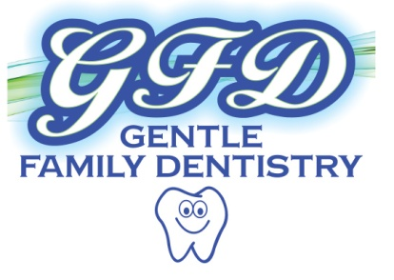
2431 Easton Avenue, Bethlehem, PA 18017 (610) 861-0190
1050 S. Cedar Crest Blvd., Suite 104, Allentown, PA 18103 (610)973-2090

NOTICE OF PRIVACY PRACTICES

THIS NOTICE DESCRIBES HOW MEDICAL INFORMATION ABOUT YOU MAY BE USED AND DISCLOSED AND HOW YOU CAN GET ACCESS TO THIS INFORMATION. PLEASE REVIEW IT CAREFULLY.
Our commitment here at GENTLE FAMILY DENTISTRY is to serve our customers with special care and professionalism, being sure at all times to protect privacy and security of all Protected Health Information.
During the course of serving your interests it may be necessary to share information with other Health Care Providers or Business Associates. The following are examples of instances where information may be shared:
- During treatment, we may find it necessary to acquire a laboratory analysis.
- For payment purposes, we may use the services of billing service.
- During health care operations, we may need a second opinion.
We here at GENTLE FAMILY DENTISTRY are committed to observe all federal, state, and local laws and regulations regarding Privacy practices. If any other uses or disclosures other than the ones listed above are needed, information will only be released with the written authorization of the individual in question. This written authorization may be revoked at any time by the individual, as provided by law.
If you have any questions or comments regarding your protection health information, please contact our office at (610)861-0190.
I have read and understand the above Notice of Privacy Practices.
Signed_________________________________________ Date__________________________
_{(Patient or legal Guardian)}
Print Name_____________________________________
NEXT PAGE PLEASE

